**Learning Outcomes**

1. Understanding Facebook SDK
2. Implementing SSO (Single Sign On) Login Button via Facebook

**UI Output**

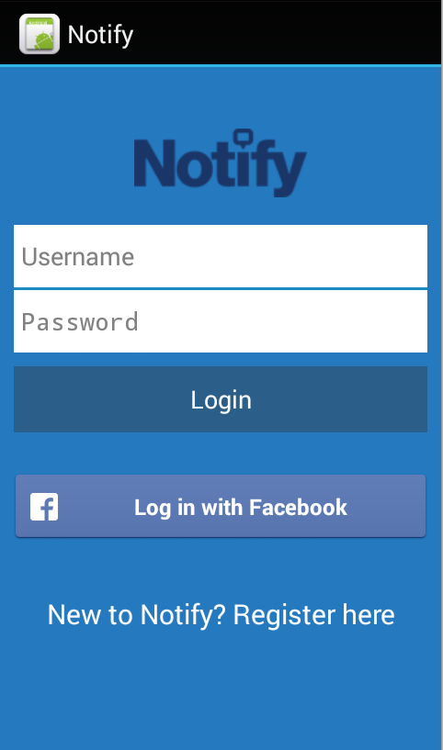

**Registering your APP on FACEBOOK**



1. Select the android platform

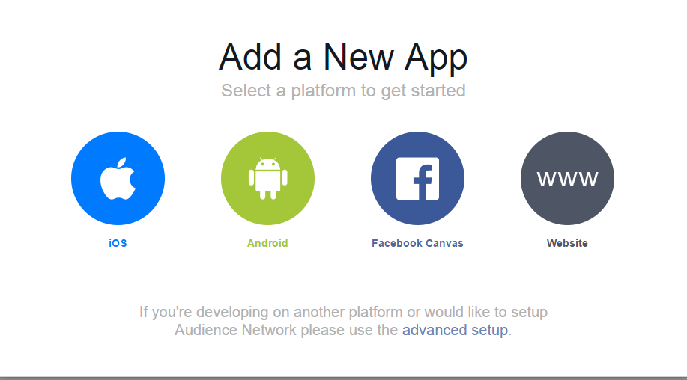

1. Type the name of your new app “ APP-name” and click create new Facebook App ID.

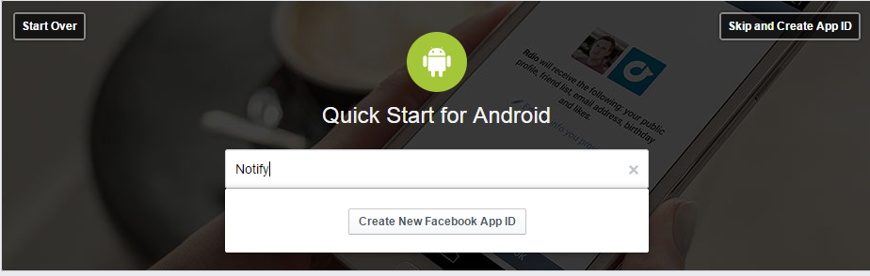

1. Create a new app ID

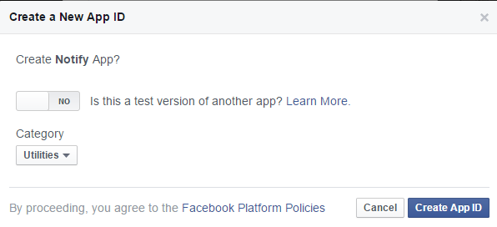

1. Once the app ID is generated we need further information about the app to give to Facebook

* Package Name
* First Activity Name
* Development and Release Key Hashes

**Package Name**

1. Create a new Android Application called “Notify”

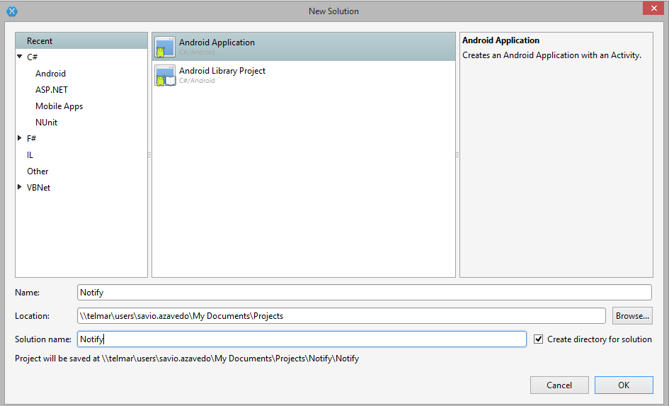

1. To get your package name , Go to your AndroidManifest.xml file

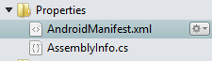

You will see the Package name from your App.

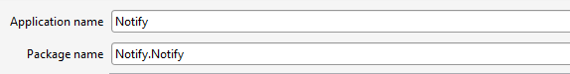

**First Activity**

Your first activity is the package name and the main activity.

**Notify.Notify.MainActivity**

**Development Key Hashes**

This is the trickiest of all the steps

You can generate a new keystore file or use the default android debug keystore file.

For Xamarin the android debug keystore file is located in

C:\Users\[username] \AppData\Local\Xamarin\Mono for Android

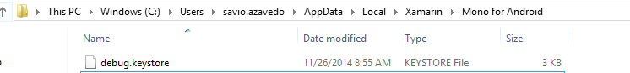

To read the SSL key hash we have to follow some steps. Find the detailed steps at the end of the document.

But there is a tool that we can use for now. Facebook HashKey

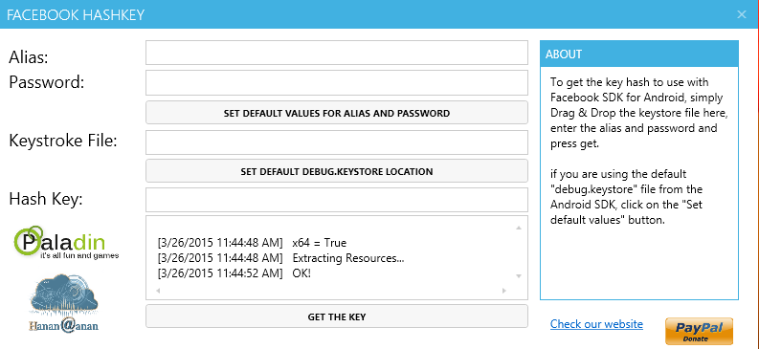

You can download it form the link below

[**https://www.androidfilehost.com/?fid=95864024717072835**](https://www.androidfilehost.com/?fid=95864024717072835)

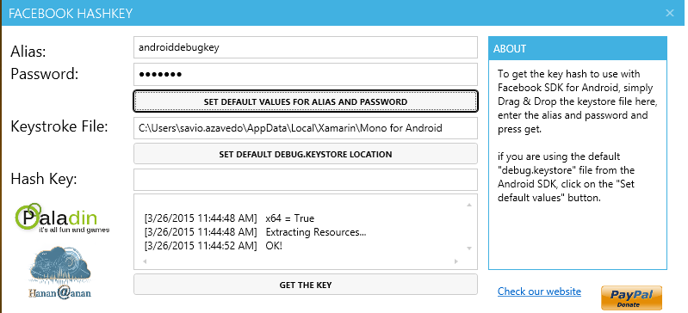

Drag and Drop the debug.keystore file on the app.

You can click the Set Default Values for Alias and Password.

Or Type Alias : **androiddebugkey** and Password : **android**

Click GET THE KEY

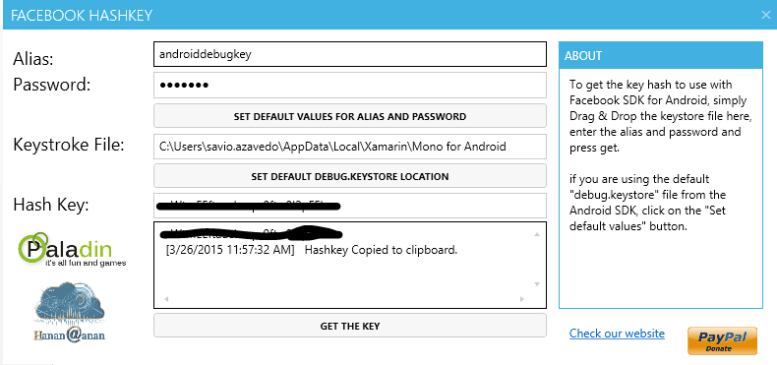

Copy the HASH Key.

Now back to your Facebook screen , Paste your development key hash in the textbox shown below.

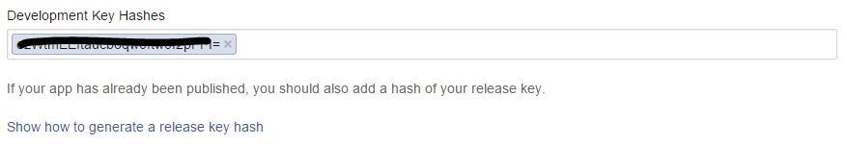

Press the Next Button and you should be good to GO

**Xamarin Project**

1. Need to modify your AndroidManifest.xml file to include the facebook Login Activity as shown below.

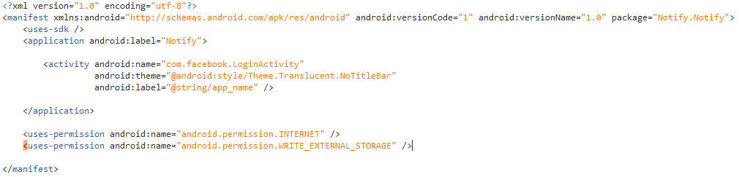

1. Obtaining the APPID (Go to your facebook dashboard and copy the App ID)

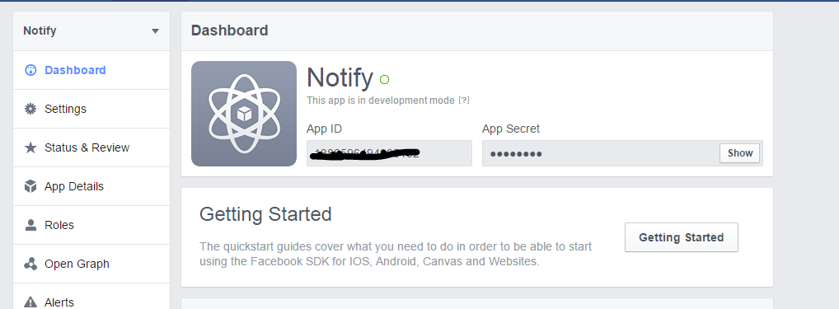

Now in the String.xml file paste the AppID

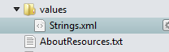

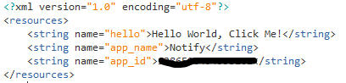

1. Add the Facebook SDK component from Xamarin component store

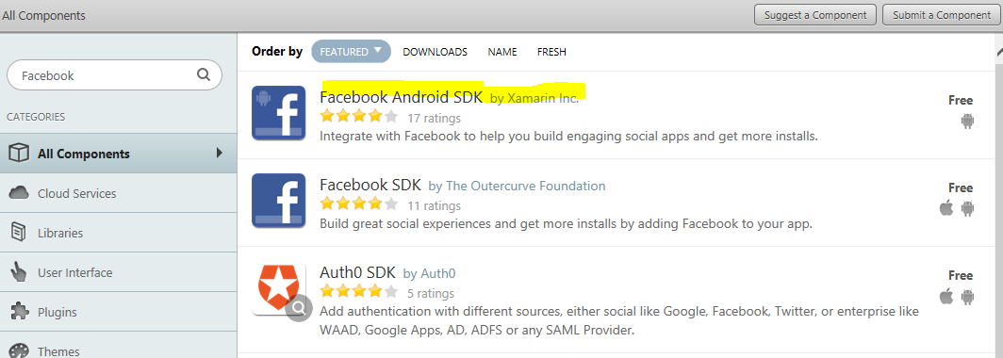

There are two on the app store select the one by Xamarin.

After adding the package you should receive the successful message in the console.

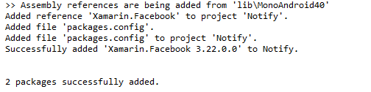

Build your project and check to see if any errors have occurred.

**Designing the UI and adding the Facebook Login Button**

Copy the XML file for the login screen given to you or you could use yours

To add the Facebook Login button, you can paste the following xml tag to your login screen.

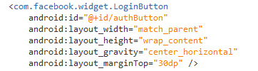

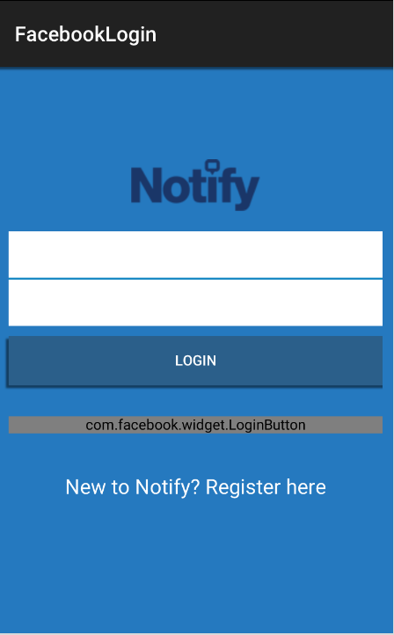

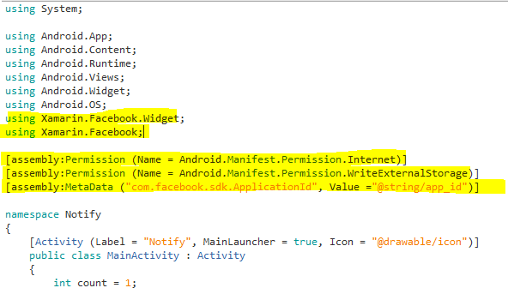

Now we need to Inherit MainActivity from Activity , Session.IStatusCallback and Request.IGraphUserCallback

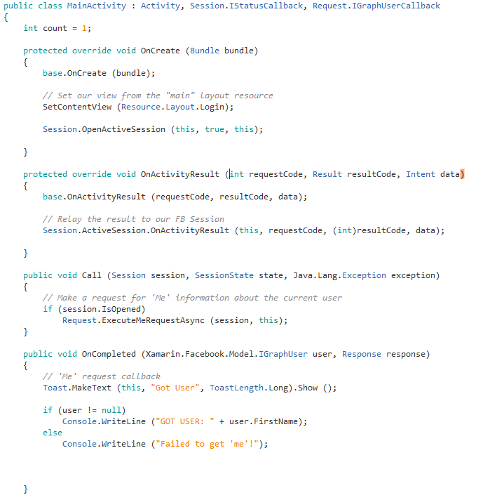

**On the Device**

Run the app and check if it works.

**On the Emulator**

To run the app in the Emulator you need to install Facebook.apk through adb

So go to your Platform tools for Android sdk and type the following.

Copy Facebook.sdk in your platform tools

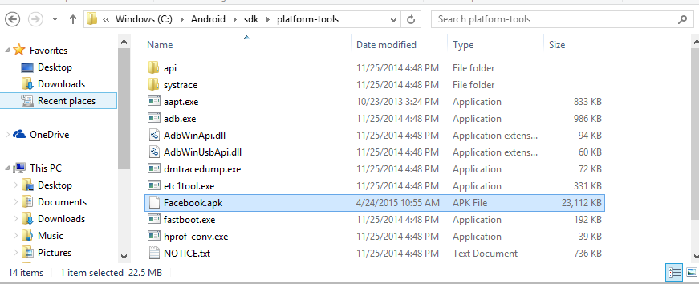

The install it from the command prompt



**Obtaining the User Details**

In MainActivity.cs, in the OnCompleted method Start a new activity to show the user details.

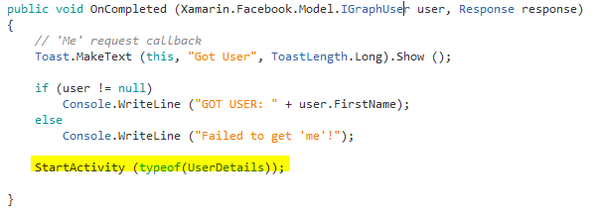

Create a new layout and activity

For the profile picture use the **com.facebook.widget.ProfilePictureView**

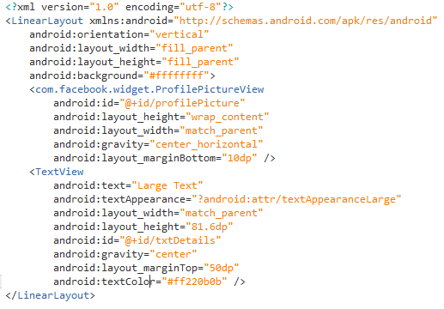

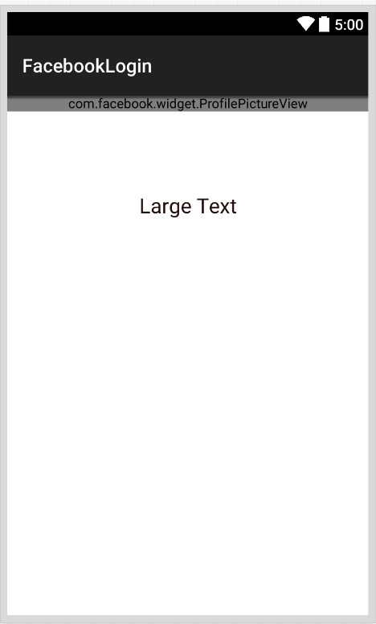

**UserDetails.cs**

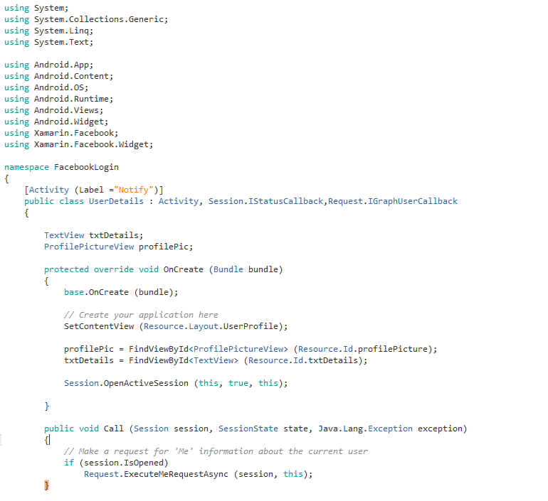

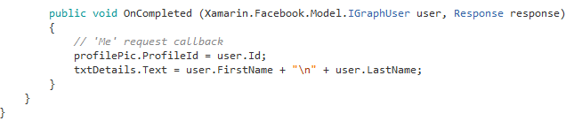

**Notes**

In order to generate key hash you need to follow some easy steps.

1) Download Openssl

2) Make a **openssl** folder in **C** drive

3) Extract Zip files into this **openssl** folder created in **C** Drive.

4) Copy the File **debug.keystore** from **.android** folder in my case

(C:\Users\SYSTEM.android) and paste into JDK bin Folder in my case (C:\Program Files\Java\jdk1.6.0_05\bin)

5) **Open command prompt** and give the path of JDK Bin folder in my case (C:\Program Files\Java\jdk1.6.0_05\bin).

6) Copy the following code and hit enter

keytool -exportcert -alias androiddebugkey -keystore debug.keystore > c:\openssl\bin\debug.txt

7) Now you need to **enter password**, Password = android.

8) If you see in **openssl** Bin folder, you will get a file with the name of **debug.txt**

9) Now either you can restart command prompt or work with existing command prompt

10) get back to C drive and **give the path of openssl Bin** folder

11) copy the following code and paste

openssl sha1 -binary debug.txt > debug_sha.txt

12) you will get **debug_sha.txt** in openssl bin folder

13) Again copy following code and paste

openssl base64 -in debug_sha.txt > debug_base64.txt

14) you will get **debug_base64.txt** in openssl bin folder

15) open **debug_base64.txt** file Here is your Key hash